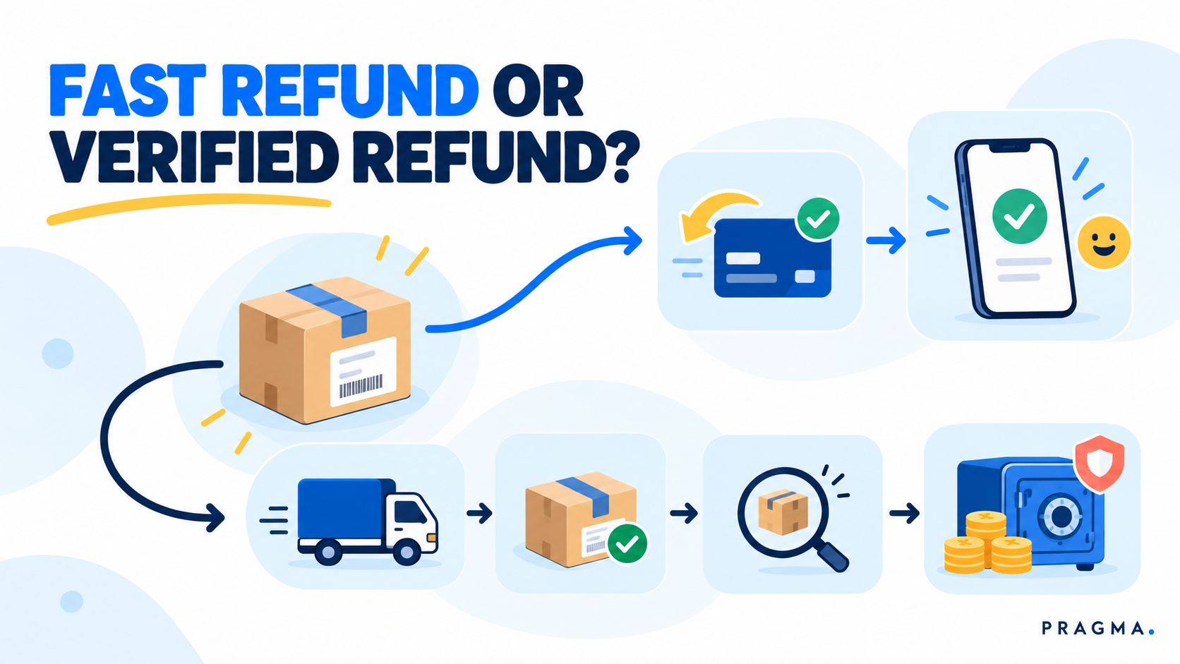

Refund Timing Impact: Instant vs Delayed Refunds for Cash Flow and NPS
A shopper whose return has been approved may expect their money back immediately. But the merchant may still be waiting for the reverse pickup, the parcel receipt, or evidence that the item can be resold. The refund timing decision therefore changes both the customer experience and the amount of cash exposed before the return is resolved.
Neither instant nor delayed refunds are automatically better. The useful policy gives a fast refund when the remaining loss is controlled, and waits for stronger evidence when an incorrect refund, missing item, or damaged return would materially affect recovery.
“Refund Timing Impact: Instant vs Delayed Refunds for Cash Flow and NPS” explains how to choose a refund trigger, measure the cash-flow and customer-experience trade-off, and test a policy without treating every return the same way.
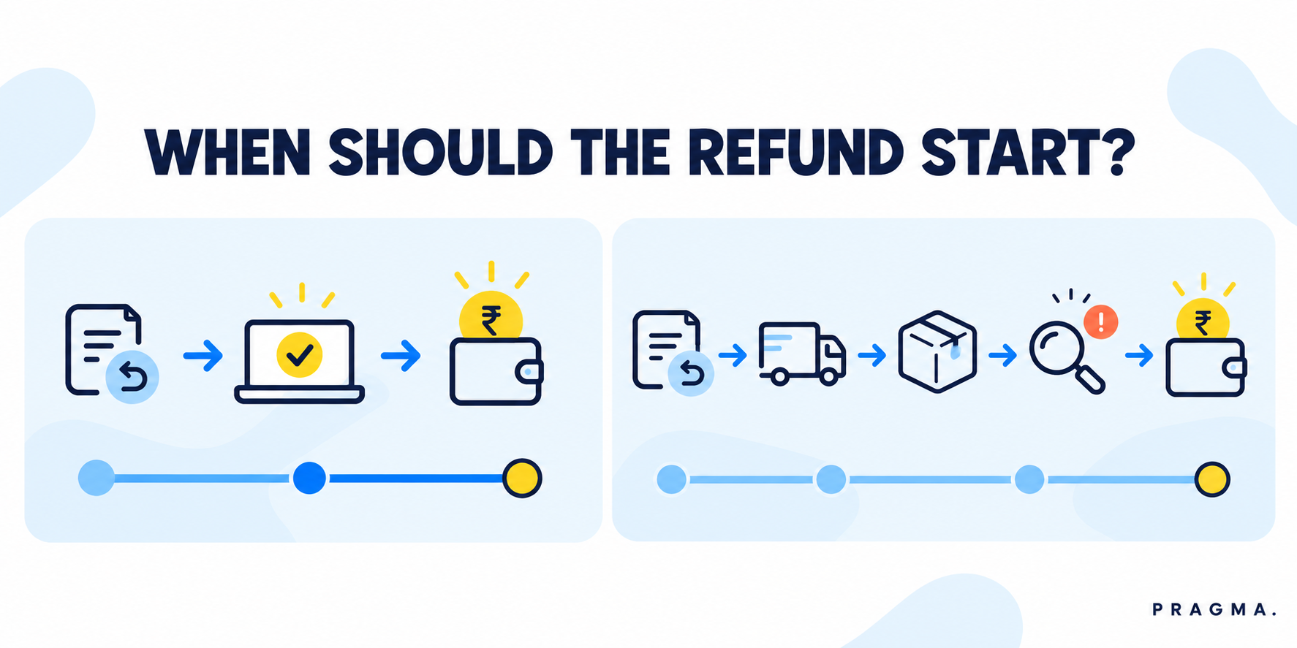

What Refund Timing Really Controls
Refund timing is the event that authorises money to leave the merchant’s account after a return request. It is not simply the number of days printed in a policy. The trigger may be approval, reverse-pickup scan, carrier acceptance, warehouse receipt, or quality-control completion.
The right trigger depends on what still has to go right after the customer sees the refund status. If the parcel is likely to be collected, received, and recovered at a predictable cost, a faster trigger may be reasonable. If the product is high-value, condition-sensitive, serialised, or supported by inconsistent evidence, an earlier refund creates more exposure.

Instant and Delayed Refunds Are Not Two Fixed Journeys
An instant refund usually starts after eligibility is confirmed or a return is approved. The customer sees a quick resolution, while the merchant accepts that pickup, receipt, and product condition will be verified later.
A delayed refund starts after a later operational event. It may wait for a pickup scan, a parcel received at the returns location, or a QC outcome. This gives the merchant stronger proof, but the customer experiences a longer wait and needs clear status communication while it happens.
The most useful comparison is therefore not “fast versus slow.” It is the amount of unresolved return risk the merchant accepts in exchange for a faster customer outcome.

Cash Flow and NPS Need Different Measures
Cash flow asks when the refund is initiated, how much cash is outstanding across open returns, and whether the eventual return outcome matches the earlier decision. It is a portfolio question: a small exposure per return can become meaningful when many approved refunds remain uncollected or unresolved.
NPS ecommerce measurement asks a different question: whether the customer felt the process was fair, understandable, and proportionate. A fast refund can support that experience, but a missed promise, confusing hold, or silent QC delay can reduce it even when the final outcome is correct.

Do Not Treat a Refund Status as the Customer Experience
Record the time from request to eligibility decision, the time to refund initiation, and the time until funds are available where that information is available. Then pair those timestamps with return-related CSAT or NPS, repeat contact rate, complaints, and repeat purchase.
The merchant should also disclose return and refund terms clearly. India’s Consumer Protection (E-Commerce) Rules require e-commerce entities to provide accurate information about return, refund, exchange, warranty, and related terms; the policy should make the refund trigger understandable before a customer needs it. The Department of Consumer Affairs lists the rules and related consumer-protection material.

Map the Evidence Before Selecting a Refund Trigger
The trigger should follow the evidence boundary. A payment decision made before the return has been collected is based on different information from one made after receipt and QC. Naming the boundary makes the rule easier to explain, audit, and improve.

Separate the Five Return Events
For each return route, record these events separately:
1. Return request: The customer states the reason and supplies any required details or media.
2. Eligibility approval: The merchant decides whether the request meets the policy.
3. Reverse pickup or carrier scan: The customer has handed the item into the return journey.
4. Parcel receipt: A return location records the parcel as received.
5. Quality-control outcome: The item’s condition, included parts, identity, and next disposition are verified.
These are operational facts, not interchangeable labels. A carrier label created by itself is not pickup proof. A parcel receipt does not prove that all accessories are present. QC does not always need to delay every low-risk refund. The policy should state which event is sufficient for each cohort.

Find Where Earlier Refunds Create Loss
Start with completed returns, not only approved requests. Compare the original trigger with the final outcome by SKU, product value, return reason, customer history, pickup success, warehouse, and carrier route.
Look for the cohort where an early refund is least likely to be matched by an acceptable return outcome. Common examples include repeated uncollected pickups, missing or substituted items, products that lose value after use, and returns whose condition determines whether resale is possible.
Also look for the opposite cohort: low-value items where reverse pickup, processing, and delay cost more than the recovery likely to be achieved. A returnless refund or an approval-triggered refund can be more sensible there, provided claim frequency and customer safeguards remain controlled.

Define the Recovery Boundary Before You Calculate Savings
Recovery is not the original selling price. It is the value actually expected after reverse freight, handling, QC, repacking, markdown, and the probability that the item will be resold. A policy that delays a refund to protect a recovery value that cannot realistically be achieved does not improve cash flow or margin.
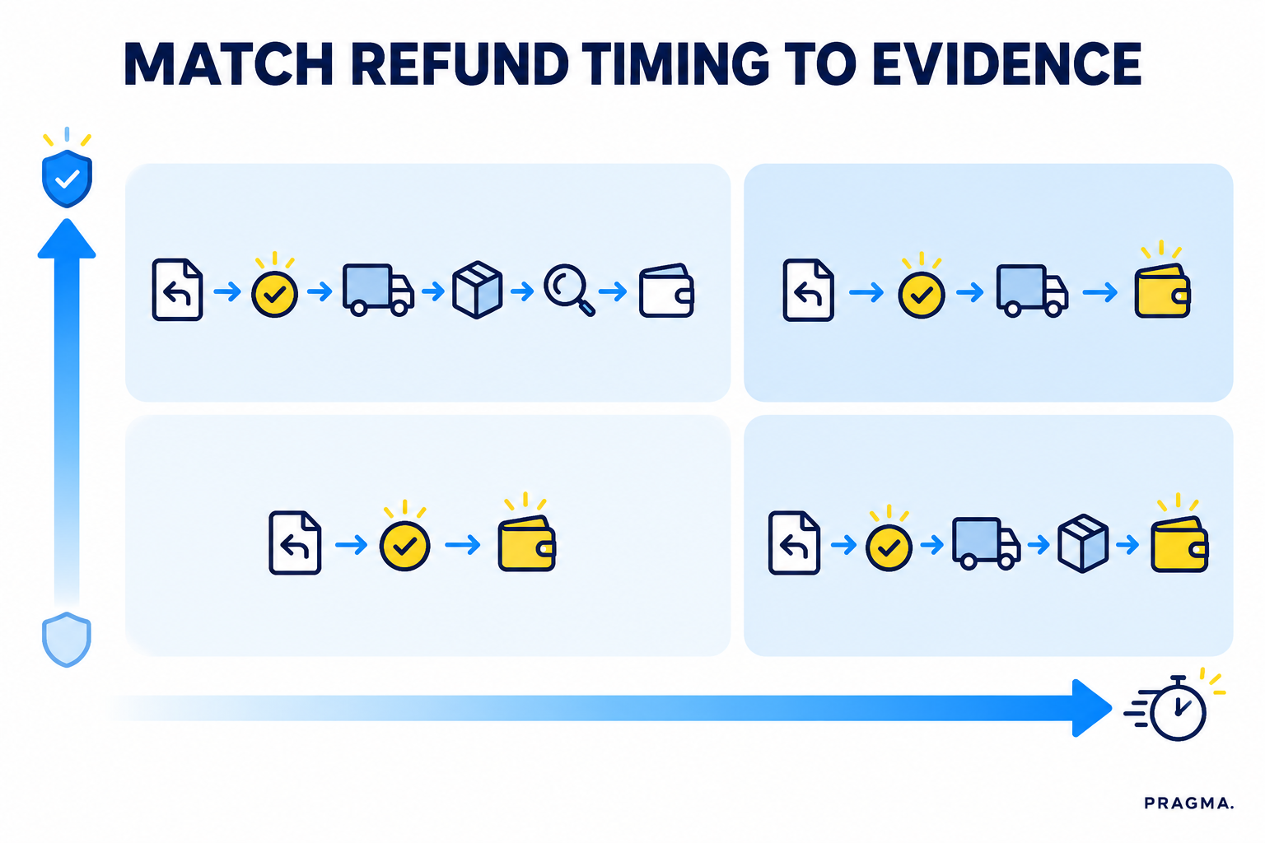

Build a Proportionate Refund-Timing Policy
The policy needs more than a default number of days. It should select the earliest trigger that is consistent with the product’s exposure, the quality of evidence, and a fair customer journey.

Use an Evidence Ladder Instead of One Global Rule
An approval trigger can suit a clear low-exposure case: the item has limited recovery value, the request evidence is consistent, and the customer or order history does not show a pattern requiring extra review. Explain the refund status immediately and retain the ability to investigate unusual exceptions.
A pickup-scan trigger can suit a return where physical collection materially reduces uncertainty but receipt and full QC are not required before releasing funds. This is often a practical middle position: the customer has completed the handover, while the merchant is not paying before the return enters the reverse network.
A receipt or QC trigger can suit a high-value, serialised, condition-sensitive, or incomplete-evidence return. The customer should see the required step, the expected review point, and the next status update. A vague “refund pending” message is not a substitute for a disclosed rule.

When to Use an Instant Approval Trigger
Use this only where the downside of a failed or imperfect return is within the merchant’s approved tolerance. Relevant inputs can include low expected recovery, brand-caused defect evidence, trusted repeat customer context, or a returnless route where pickup itself would be uneconomic.
Fast should not mean unobserved. Monitor returns that were refunded at approval but never collected, received, or reconciled. Investigate patterns by return reason and cohort before tightening the entire policy.

When to Wait for Pickup, Receipt, or QC
Move the trigger later when the evidence needed to protect the decision has not yet arrived. Examples include a missing serial number, an expensive item with uncertain condition, a return that affects exchange inventory, or a claim with conflicting media and order evidence.
The waiting period must be proportionate. If a carrier scan is enough to control the real risk, waiting for an internal QC queue may create unnecessary customer frustration. If QC is essential, define a service target and provide updates instead of leaving the customer to chase support.

Keep Exceptions Clear and Reversible
Every rule needs a reason code, owner, review date, and manual override route. A customer with a genuine damaged-item claim should not be forced through the same wait as an ambiguous return merely because they share a SKU.
Set the exception message in the same system as the rule. Support agents should be able to see what event is awaited, why it is awaited, and what action can resolve it. That prevents inconsistent explanations and unauthorised promise-making.
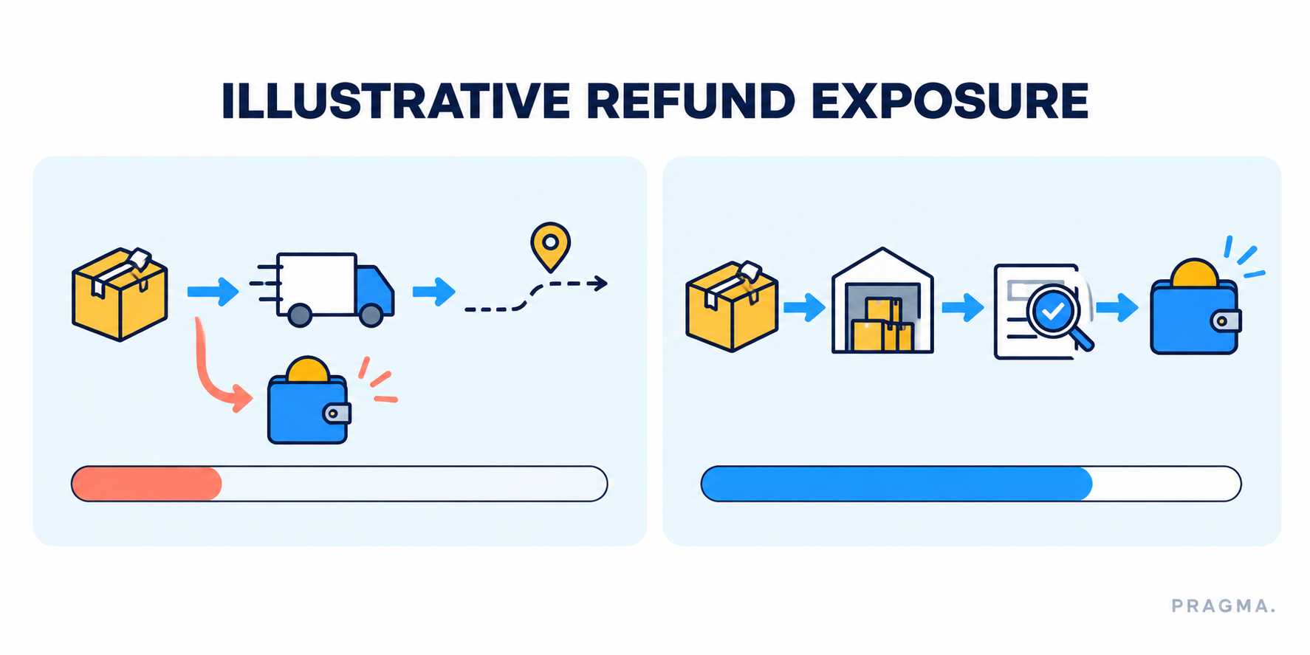

Measure Refund Timing Impact on Cash Flow and NPS
Measure the policy on the complete return lifecycle. Faster approval can make a dashboard look better while simply moving unresolved cash exposure later in the journey. Delayed refunds can reduce early exposure while creating contacts, complaints, and customer distrust that do not appear in a reverse-logistics report.

Calculate Outstanding Refund Exposure
For a defined cohort, start with refunds initiated before their final return outcome. Then isolate the cases that later become uncollected, unreconciled, ineligible, materially damaged, or lower-recovery than expected.
Outstanding early-refund exposure = refunds initiated before final outcome × probability of an adverse outcome × expected unrecovered amount.
Use the actual cohort outcome where enough volume exists, rather than applying one global probability. A footwear return during a sale, a low-value accessory, and a sealed high-AOV product are different exposure profiles.

Include the Cost of Waiting as Well
The cash calculation is incomplete if it omits the customer cost of delay. Track request-to-refund time at the median, 75th percentile, and 95th percentile; support contacts per return; complaints; return-related CSAT or NPS; and repeat purchase after the return is closed.
NPS is best used as a directional guardrail, not as proof that one trigger caused loyalty. Compare like-for-like cohorts and read open-text feedback alongside the score. A sudden score change may reflect policy wording, delivery experience, or the reason for return—not refund timing alone.

Compare Policy Outcomes by Cohort
Report at least these measures for every trigger and cohort:
• Refund initiation time and final refund-completion time
• Refunds initiated before pickup, receipt, and QC
• Pickup completion, parcel-receipt, and reconciliation rates
• Expected versus realised recovery value
• Return-related CSAT or NPS, complaints, and repeat contacts
• Repeat purchase, manual overrides, and repeat claim frequency
• Net refund loss after reverse-logistics and handling costs
This prevents an apparent improvement from hiding in one metric. A shorter wait may be worth a controlled increase in exposure. A lower exposure may be worth a slightly later trigger if customers understand the reason and the policy still meets the brand’s service promise.
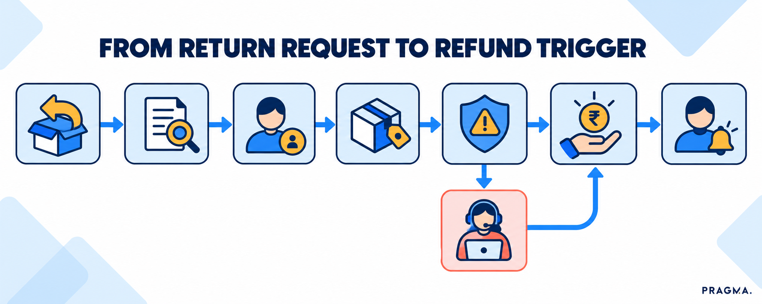

Test Refund Timing Before Changing Every Return
A full-policy switch makes it difficult to tell whether a result came from timing, seasonality, a carrier problem, a product-quality issue, or a change in customer mix. Start with one cohort where the exposure and customer need are both meaningful.

Select a Controlled Pilot Cohort
Choose a stable SKU group, category, return reason, or value band. Document the current trigger, the proposed trigger, the customer message, the expected financial effect, the customer-experience safeguard, and the rollback condition.
Keep comparison groups comparable. If one group receives faster refunds only because it contains lower-value or less risky products, it does not show that the trigger itself improved the outcome. Where a simultaneous control is not practical, use a defined pre-period with the same eligibility conditions and state that limitation.

Set Success and Rollback Conditions in Advance
The pilot can scale only when the full decision improves. Define what counts as a material improvement in refund time or customer experience, the maximum accepted increase in unresolved exposure, and the complaint or contact threshold that triggers investigation.
Review a return cohort until it reaches final disposition. Approval data alone cannot show whether the merchant recovered the item, received the expected value, or created a customer problem later in the journey.
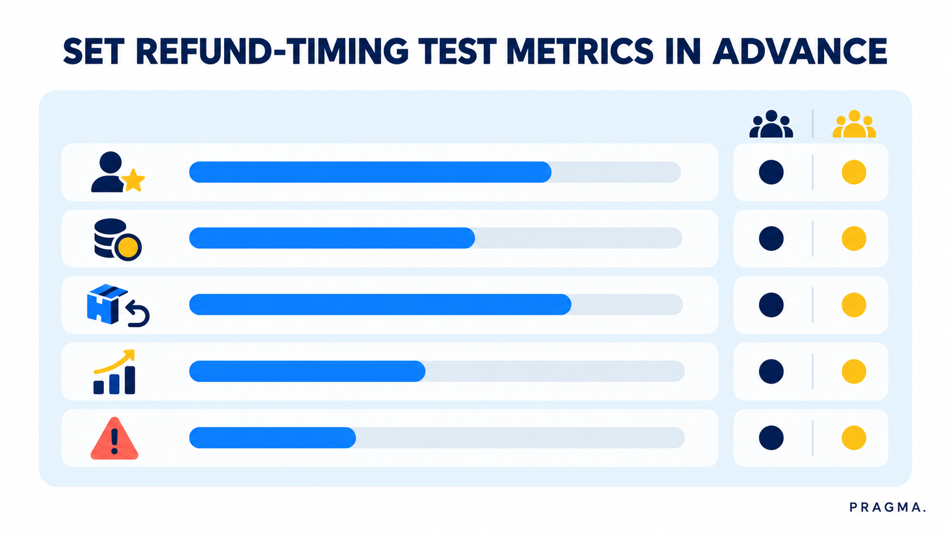

How Pragma RMS Supports Refund-Timing Decisions
Pragma RMS gives brands configurable return eligibility and return windows by SKU, product category, and seasonal sale. Those controls help establish who can initiate a return before the refund-timing rule is applied.

Capture Evidence and Route Returns Deliberately
Pragma RMS supports reason-based media upload and verification, which can help brands collect the evidence a particular return path requires. Its reverse-shipment workflow can generate reverse AWBs after approval and map SKU selections to warehouses, shipping partners, and timings, subject to the merchant’s setup and available integrations.
Use those controls to make the timing policy consistent: request the right evidence, choose the appropriate reverse route, record the event that authorises the refund, and send the customer a clear status. The product should support the policy; it does not remove the merchant’s need to define tolerance, exception handling, or customer safeguards.

Connect Refund Rules With Return Analytics
The useful review is not a single average refund time. Segment outcomes by trigger, SKU, return reason, value band, customer cohort, carrier outcome, and final disposition. That lets the team see whether a later event genuinely protected recovery or simply introduced a longer wait.
Pragma’s broader returns-management process guide is a useful next reference for the return workflow around eligibility, reverse logistics, and refund execution.

To Wrap It Up: Make Refund Speed a Controlled Decision
Start with the earliest refund trigger that the evidence can justify. Faster refunds are valuable when the remaining exposure is accepted, visible, and monitored. Later refunds are justified only when the additional proof protects a meaningful recovery or prevents a measurable loss.
The customer should always know what happens next. A clear trigger, realistic service target, and consistent exception path make a delayed refund easier to understand—and a fast refund easier to operate without silently increasing risk.
Methodology note: The framework and formulas in this article are illustrative. Each merchant should establish its own cash-flow, recovery, customer-experience, and policy baseline before setting a refund trigger.
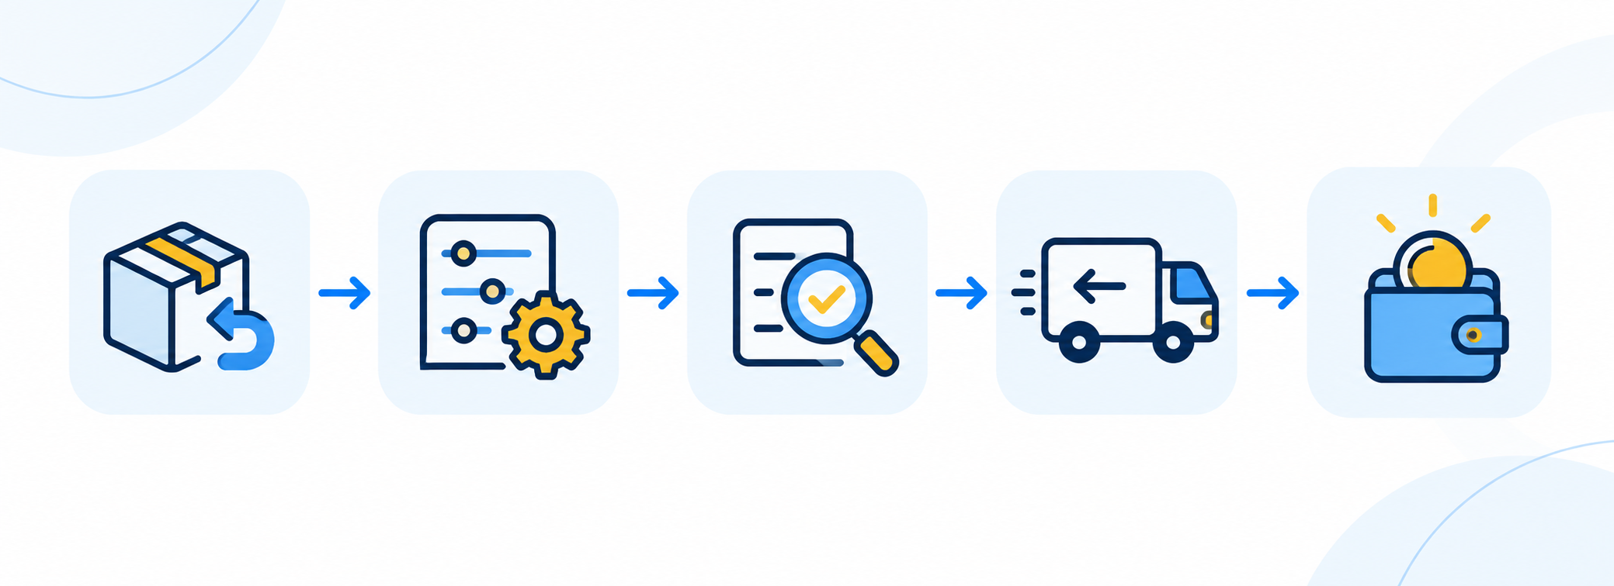

FAQs (Frequently Asked Questions On Refund Timing Impact: Instant vs Delayed Refunds for Cash Flow and NPS)

1\. What is the difference between an instant and a delayed refund?
An instant refund starts at an early event, commonly eligibility approval. A delayed refund starts after a later event such as pickup, receipt, or QC. The difference is the amount of return risk the merchant accepts before releasing funds.

2\. Does an instant refund always improve NPS ecommerce results?
No. Speed can improve the experience, but clarity, fairness, and whether the brand meets the stated promise also matter. Compare return-related NPS or CSAT with complaints, contacts, and open-text feedback for comparable cohorts.

3\. When should a brand wait for a pickup scan before refunding?
A pickup scan can be a useful trigger when physical handover reduces a meaningful risk but full warehouse QC is unnecessary. Test whether it improves pickup completion or exposure enough to justify the added wait.

4\. How can a merchant measure early-refund exposure?
Track refunds initiated before the final return outcome, then identify the returns that were uncollected, unreconciled, ineligible, damaged, or lower-recovery than expected. Calculate the unrecovered amount after reverse-logistics and handling costs by comparable cohort.

5\. Should high-value returns always wait for quality control?
Not always. Value is one input, but serialisation, product condition, evidence quality, customer context, and recovery potential also matter. If a pickup scan controls the relevant risk, waiting for QC may add avoidable delay.

6\. Can a returnless refund improve cash flow?
It can avoid reverse-pickup and processing costs where expected recovery is low, but it also leaves the customer with the item. Limit it to eligible cohorts and monitor claim frequency, repeat use, and customer safeguards.

7\. Which metrics should be reviewed before changing refund timing?
Review refund time, outstanding early-refund exposure, pickup and receipt completion, realised recovery, net refund loss, return-related CSAT or NPS, complaints, repeat contacts, manual overrides, and repeat purchase. Use a defined control or baseline before scaling a change.

TL;DR
Refund timing should follow the evidence needed to protect the decision. Approval-based refunds can reduce customer wait when exposure is controlled; pickup, receipt, or QC triggers are appropriate when later proof materially protects recovery. Test the rule against both cash exposure and customer experience rather than optimising for speed alone.

Key Takeaways
• Choose an explicit trigger: Approval, pickup, receipt, and QC are different evidence boundaries.
• Measure cash exposure after the final outcome: A fast approval is not proof that the return was recovered.
• Treat NPS as a guardrail: Pair it with contacts, complaints, and policy clarity.
• Use the earliest proportionate trigger: Do not delay every low-risk return or instantly refund every high-exposure one.
• Pilot before scaling: Define cohort, control, success criteria, and rollback signal in advance.

How Pragma RMS Supports Refund Timing
Pragma RMS supports SKU-, category-, and sale-level return eligibility and window configuration, along with reason-based media verification. These controls can help a team collect the right return evidence before it applies a merchant-defined refund rule.
Its reverse-shipment workflow can generate reverse AWBs after approval and route returns by SKU to the appropriate warehouse, partner, and timing configuration. Review outcomes by trigger and final disposition so the policy remains both customer-safe and commercially sound.
Configurable return eligibility, verification, and reverse-routing workflows
Explore Pragma RMS

FAQ JSON-LD Schema
{
"@context": "https://schema.org",
"@type": "FAQPage",
"mainEntity": [
{
"@type": "Question",
"name": "What is the difference between an instant and a delayed refund?",
"acceptedAnswer": {
"@type": "Answer",
"text": "An instant refund starts at an early event, commonly eligibility approval. A delayed refund starts after a later event such as pickup, receipt, or QC. The difference is the amount of return risk the merchant accepts before releasing funds."
}
},
{
"@type": "Question",
"name": "Does an instant refund always improve NPS ecommerce results?",
"acceptedAnswer": {
"@type": "Answer",
"text": "No. Speed can improve the experience, but clarity, fairness, and whether the brand meets the stated promise also matter. Compare return-related NPS or CSAT with complaints, contacts, and open-text feedback for comparable cohorts."
}
},
{
"@type": "Question",
"name": "When should a brand wait for a pickup scan before refunding?",
"acceptedAnswer": {
"@type": "Answer",
"text": "A pickup scan can be a useful trigger when physical handover reduces a meaningful risk but full warehouse QC is unnecessary. Test whether it improves pickup completion or exposure enough to justify the added wait."
}
},
{
"@type": "Question",
"name": "How can a merchant measure early-refund exposure?",
"acceptedAnswer": {
"@type": "Answer",
"text": "Track refunds initiated before the final return outcome, then identify the returns that were uncollected, unreconciled, ineligible, damaged, or lower-recovery than expected. Calculate the unrecovered amount after reverse-logistics and handling costs by comparable cohort."
}
},
{
"@type": "Question",
"name": "Should high-value returns always wait for quality control?",
"acceptedAnswer": {
"@type": "Answer",
"text": "Not always. Value is one input, but serialisation, product condition, evidence quality, customer context, and recovery potential also matter. If a pickup scan controls the relevant risk, waiting for QC may add avoidable delay."
}
},
{
"@type": "Question",
"name": "Can a returnless refund improve cash flow?",
"acceptedAnswer": {
"@type": "Answer",
"text": "It can avoid reverse-pickup and processing costs where expected recovery is low, but it also leaves the customer with the item. Limit it to eligible cohorts and monitor claim frequency, repeat use, and customer safeguards."
}
},
{
"@type": "Question",
"name": "Which metrics should be reviewed before changing refund timing?",
"acceptedAnswer": {
"@type": "Answer",
"text": "Review refund time, outstanding early-refund exposure, pickup and receipt completion, realised recovery, net refund loss, return-related CSAT or NPS, complaints, repeat contacts, manual overrides, and repeat purchase. Use a defined control or baseline before scaling a change."
}
}
]
}

